

**Certificates Generations - User Guide & Installation**

*Developed by L3 System Support team*

|  |  |  |  |
| --- | --- | --- | --- |
| **Date** | **Rev** | **Author** | **Comments** |
| July 10th, 2025 | 1.1.0.3 | EL AZZOUZI Asmae | 3rd official release |

**Table of content**

1 Introduction 3

1.1 Definitions 3

1.2 Pre-requisites 4

1.3 Known limitations 4

2 Installation Guide 5

2.1 Certificates Generation Installation 5

2.2 Check Installation 7

3 User Guide 8

3.1 Folders Structure 8

3.2 Prepare Data Before Launch 8

3.3 Launch Certificates Generation 9

3.4 Logs 13

4 Annex 13

4.1 Support 13

# Introduction

This document is the **USER GUIDE** for the ***Certificates Generation*** software, ***version 1.1.0.3***

***Certificates Generation*** is developed to automate the creation of training certificates from **Excel data** and **PowerPoint templates**.

This version includes the **automatic sending of certificates via Outlook**, with certificates being emailed to participants and automatically sent in **cc** to **SAML3SSystem** for tracking purposes.

The application now also integrates **Single Sign-On (SSO)**, **email**, and **region** data, which are retrieved during the quiz process before participants proceed to the training session. This information helps in improving certificate distribution and tracking.

Work is also ongoing to build a comprehensive user list with **SSO**, **region**, and **email** to further enhance the certificate distribution process.

For any issues or feedback, please contact the **L3 System Support team** by email, providing:

* Description of the issue
* Relevant logs or attachments

## Definitions

To facilitate reading this User Guide, find hereafter some definitions of terms used.

|  |  |
| --- | --- |
| **Terms** | **Comments** |
| CEO | *Customer Experience & Operations* |
| |  |  | | --- | --- | | SSO |  | | |  |  | | --- | --- | | SSO | Single Sign-On – Used to identify the user logging into the app | |
| |  |  | | --- | --- | | PPTX |  | | *PowerPoint Presentation File* – Template file format used to generate certificates |
| |  |  | | --- | --- | | XLSX |  | | *Excel Spreadsheet File* – File format used to import participant data |
| |  |  | | --- | --- | | EXE |  | | *Executable File* – The standalone application binary (*.exe) |
| |  |  | | --- | --- | | Log |  | | *Log File* – File that records the application's events or errors |
| |  |  | | --- | --- | | Template |  | | *PPTX Certificate Layout* – File containing the certificate design and placeholders |
| |  |  | | --- | --- | | Placeholder |  | | *Dynamic Field Tag* – e.g., {{NOM}}, used to insert participant-specific data |

## Pre-requisites

* ***Certificates Generation*** is intended **exclusively for CEO team members**.
* ***Certificates Generation*** runs on ***Windows 10*** and ***Windows 11***.
* To generate certificates, ***Microsoft PowerPoint*** must be installed on the PC.
* The application requires an Excel file containing participant data **(Date Appeared, Name, N° of Attempts, Percent Score, etc.)**
* The certificate template used by the application must contain the following placeholders for dynamic replacement:
* {{NOM}} (participant name)
* {{FORMATION}} (training title)
* {{DATE_FORMATION}} (training date)
* {{DATE_EDITION}} (certificate issuance date)
* {{SSO}} (participant SSO)
* ***Certificates Generation*** is distributed as a standalone Windows executable (.exe), so there is **no need to install** Python or any additional packages for the end user.

## Known limitations

* The application does not support **MacOS** or **Linux** currently.
* User access control is limited to **Windows user login**; no additional authentication methods are implemented.
* The Excel input file must follow a **strict format for data extraction**; improper formatting may cause errors or skipped entries.

***Note:*** *A sample data file is not provided after installation. Users are required to prepare their own* ***Excel*** *file following the correct format. Ensure it includes the necessary columns (e.g., Name, Date Appeared, Percent Score, etc.).*

# Installation Guide

## Certificates Generation Installation

### Retrieve Certificates Generation Setup installation

|  |  |
| --- | --- |
| *Load* “**Setup_Certificates_Generation7z**” file from [Setup_Certificates_Generation_V1.1.0.3.7z | Powered by Box](https://gevernova.ent.box.com/file/1928829388728) |  |
| *Unzip* “**Setup_Certificates_Generation.7z**” |  |

### First-time Installation on your PC

|  |  |
| --- | --- |
| *Launch as* ***administrator*** “**Setup_Certificates_Generation_V1.1.0.3.exe**” |  |
| *Select Destination location*  Then, *Next*. |  |
| *Select Start Menu Folder*:  Select *Next* |  |
| *Select Create a Desktop icon & Start Menu Shorcut:*  *Select Next* |  |
| *Ready to Install:*  Select *Install* |  |
| Installation is finished.  You can select *Finish*. |  |
| *Installer finishes with shortcut ready for launch* |  |

## Check Installation

You can check Certificates Generation installation.

|  |  |
| --- | --- |
| With Windows explorer, go to the folder where Certificates Generation is installed.  Here to **“C:\Program files(x86) \ Certificates Generation”** |  |
| *Check Certificates Generation version.*  You can check the version of **Certificates Generation**: select “**Certificates Generation.exe**”, click right, select Properties. Then Details sheet. |  |
| *Check Certificates Generation Log folder after launching the application or running the test*  At each Audit, ***Certificates Generation*** records Logs to the folder “…**\*Certificates Generation***” |  |

# User Guide

## Folders Structure

After installation, the main folder structure is as follows:

**C:\Program Files\Certificates Generation\**

* Certificates Generation.exe ← Main application
* Template\ ← Folder containing the PowerPoint certificate template
* Data\ ← Folder containing a sample **Excel** file with participant data for testing purposes.   
  (***Note***: This file can be used to test the tool after installation)
* certificates_generation.log ← Installation logs (Created after first use)

## Prepare Data Before Launch

Before launching the application, ensure that:

* The **Excel file** with participant data is ready and formatted properly (columns must include at least: **(Date Appeared, Name, N° of Attempts, Percent Score, …)**



* The **PowerPoint template** in the Template\ folder includes the following placeholders:
  + {{NOM}}
  + {{SSO}}
  + {{FORMATION}}
  + {{DATE_FORMATION}}
  + {{DATE_EDITION}}

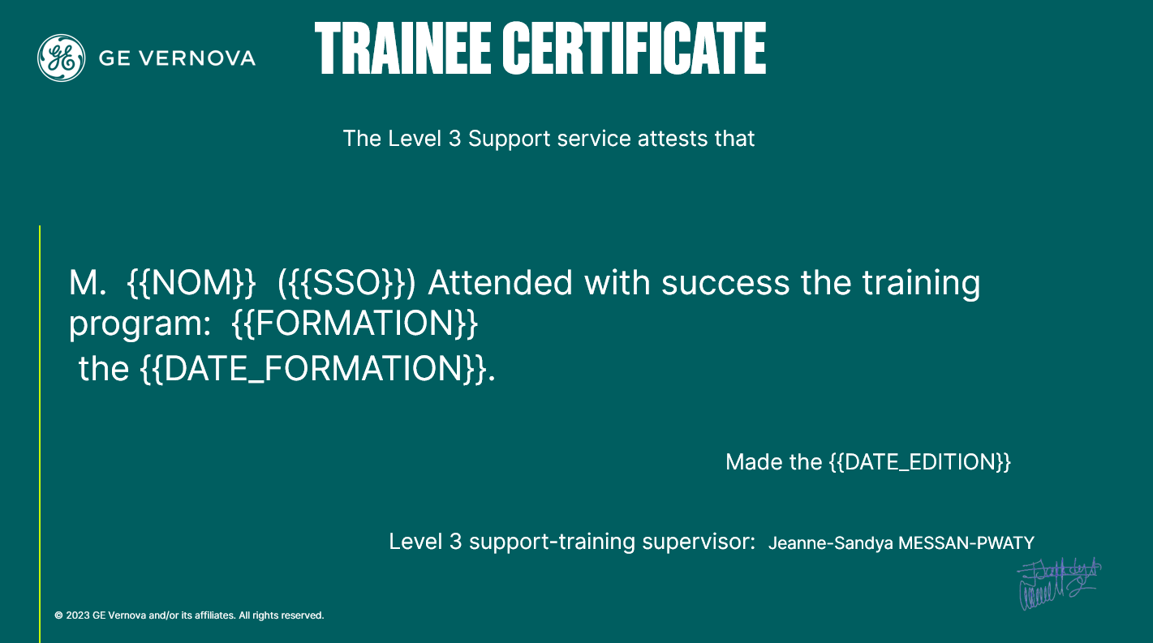

## Launch Certificates Generation

### Login Page

- Launch as administrator “Certificates Generation.exe “(click right ***Run as administrator***):

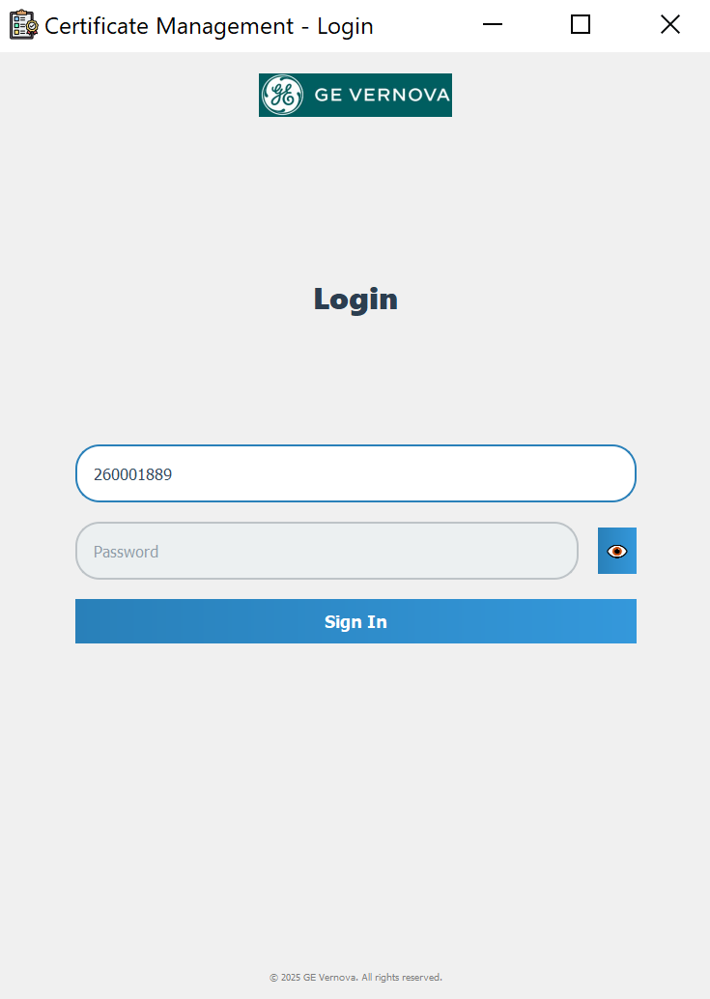

Please enter the password for your Windows session

Your SSO will serve as your personal identifier within the application

* Then, Click Sign In

### Generation Page

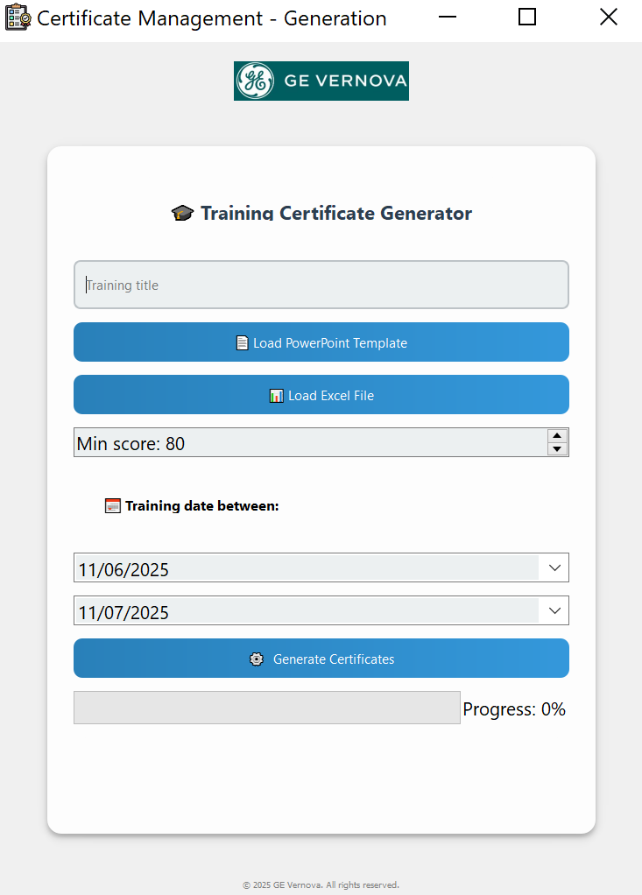

The certificate generation process consists of the following steps

1. **Enter the Training Title**  
   Type the name of the training session (**e.g., *DS Agile Level 1***).
2. **Load the PowerPoint Template**  
   Click on **"Browse"** or **"Load Template"** to select the .pptx file that contains the certificate layout.  
   ⚠️ Make sure the template includes the required placeholders:
   * {{NOM}} – Participant name
   * {{SSO}} – Participant SSO
   * {{FORMATION}} – Training title
   * {{DATE_FORMATION}} – Training date
   * {{DATE_EDITION}} – Certificate issuance date
3. **Load the Excel File**  
   Upload the Excel file that contains the list of participants and their details:
   * Date Appeared
   * Name
   * Number of Attempts
   * Percent Score, etc.
4. **Set the Minimum Score**  
   Define the minimum score (**e.g., 80%**) required to validate and issue a certificate.
5. **Select the Training Period**  
   Choose the **Start Date** and **End Date** of the training session. Only participants whose attendance falls within this date range will be considered.
6. **Click "Generate Certificates"**  
   Once all inputs are filled, click the **Generate Certificates** button.
7. **Select the destination folder where the generated certificates will be stored**  
   This folder will be used to store all generated PDF certificates for the current session.

Certificates will be created for participants who meet the score and date criteria.

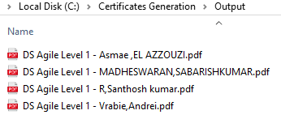 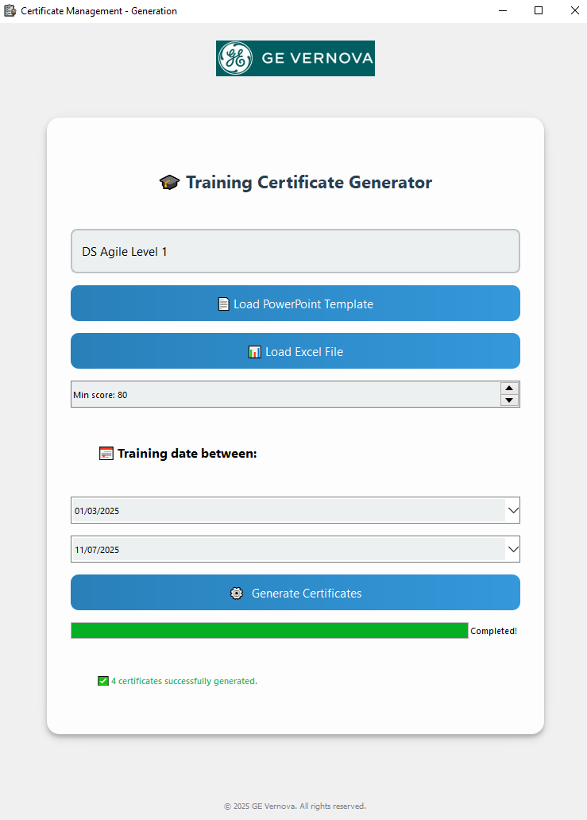

Here is an example of a generated certificate:

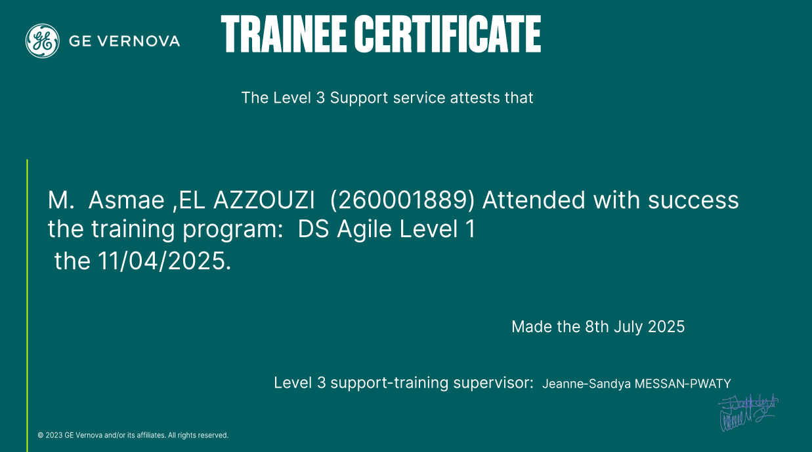

This certificate was automatically generated using the template and participant data provided through the application.

Once the certificates are generated, they will automatically be sent by email to the participants, with **SAM.L3SSystem@gevernova.com** in **CC**. The email will contain a message along with the attached PDF certificate:

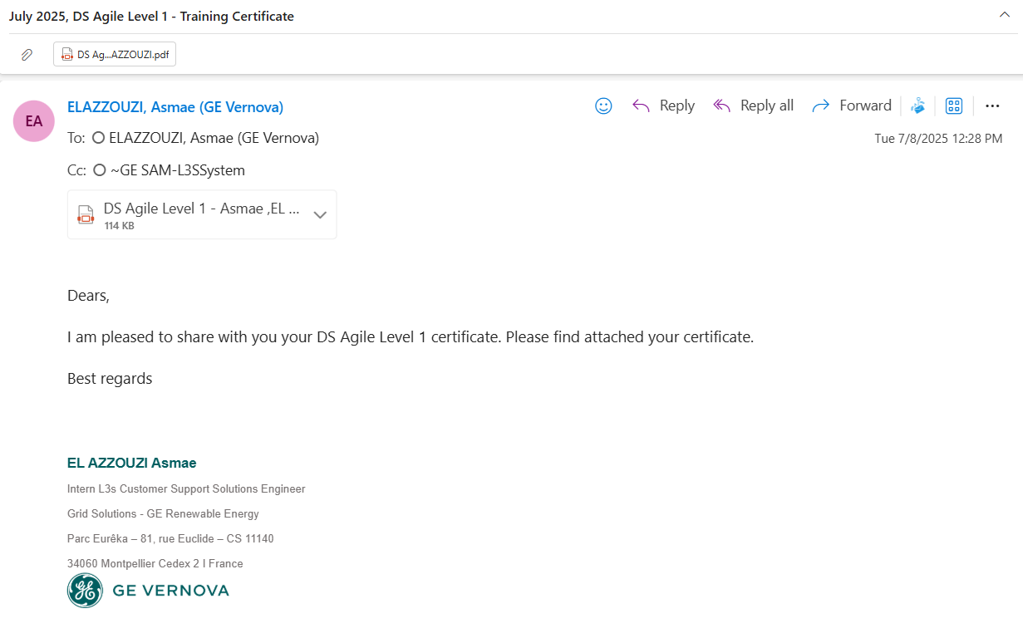

## Logs

At the end of **Certificates Generation** process**,** a log file is saved at:  
**“C:\Program Files(x86)Certificates Generation\certificates_generation.log”**

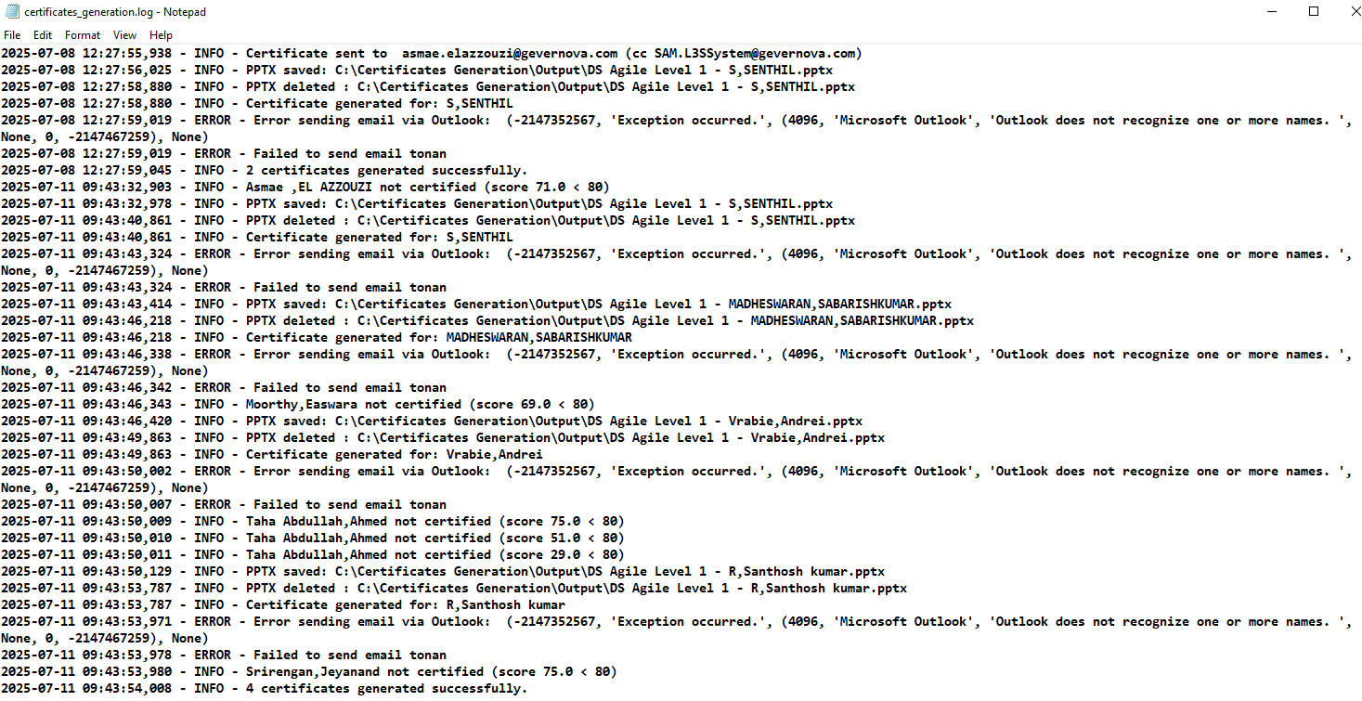

You canalso **check the installation log if needed**, in the same directory where you installed the setup:

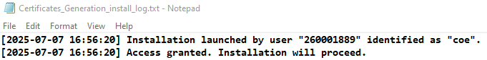

# Annex

## Support

In case of issue, request information or suggestion of evolution with **Certificates Generation**, please, send an email to L3 Support members and to [SAM.L3SSystem@ge.com](mailto:SAM.L3SSystem@ge.com)., with the following information:

* Log
* Description of issue